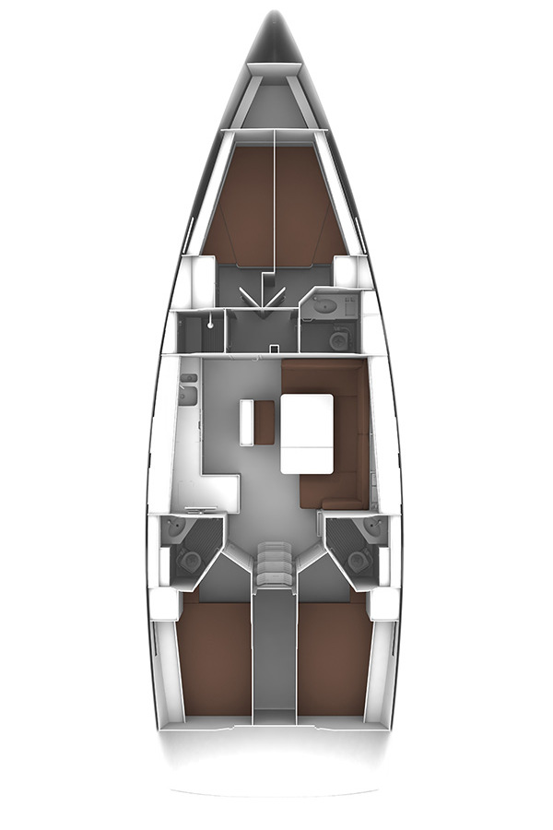

**Water filler forward tanks**

**1 under locker lid is 150L**

**2 on deck are 66L**

**Toilet waste tank pump outs x3 – on deck**

**Forward head seacocks x3 – under cabinet**

**Diesel filler – under helm foot brace**

**Aft starboard head seacocks x4 – under cabinet**

**Forward shower seacock x1 – under galley sinks**

**Water aft tank filler – under helm foot brace**

**Galley Sink sea cock – under galley sinks**

**Aft Port head seacocks x4 – under cabinet**

**Engine seawater inlet – port side of Sail drive leg**

**F1**

**F1**

**F1**